Argentina
Capital c.: Buenos Aires
Population: 44,938,712
Total area: 2 780 400 km2
Belgium
Capital c.: Brussels
Population: 11,515,793
Total area: 30,689 km2
Romania
Capital c.: Bucharest
Population: 19,401,658
Total area: 238,397 km2
Brazil
Capital c.: Brasília
Population: 210,147,125
Total area: 8,515,767 km2

Egypt
Capital c.: Cairo
Population: 99,581,200
Total area: 1,010,408 km2
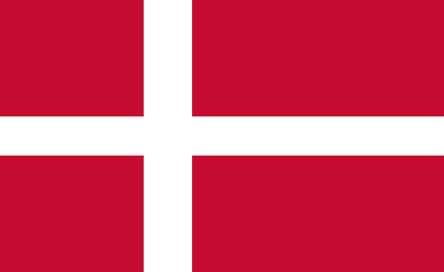
Denmark
Capital c.: Copenhagen
Population: 5,827,463
Total area: 42,933 km2
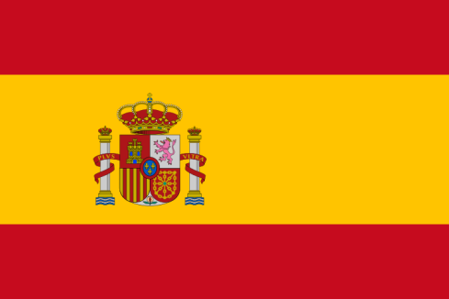
Spain
Capital c.: Madrid
Population: 46,733,038
Total area: 505,990 km2

Switzerland
Capital c.: Bern
Population: 8,570,148
Total area: 41,285 km2

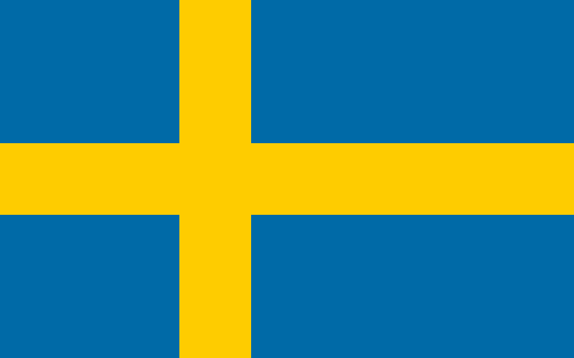
Sweden
Capital c.: Stockholm
Population: 10,302,984
Total area: 450,295 km2
Ukraine
Capital c.: Kiev
Population: 42,030,832
Total area: 603,628 km2
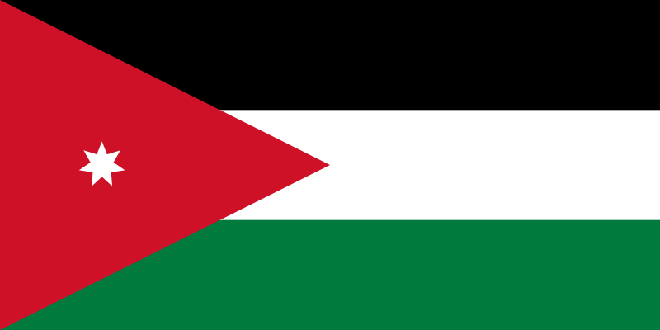
Jordan
Capital c.: Amman
Population: 10,407,793
Total area: 89,342 km2
Turkey
Capital c.: Ankara
Population: 82,003,882
Total area: 783,356 km2

Malta
Capital c.: Valletta
Population: 493,559
Total area: 316 km2
Scotland
Capital c.: Edinburgh
Population: 5,424,800
Total area: 77,933 km2
Wales
Capital c.: Cardiff
Population: 3,139,000
Total area: 20,779 km2
Israel
Capital c.: Jerusalem
Population: 9,145,360
Total area: 22,072 km2

